**CONDITIONAL STATEMENTS ASSIGNMENT**

1.) import java.util.Scanner;

public class Main

{

public static void main(String[] args) {

int n;

Scanner s = new Scanner(System.in);

System.out.println("Enter a number : ");

n=s.nextInt();

if(n>0)

System.out.println(n + " is positive");

else

System.out.println(n + " is negative");

}

}

Output:

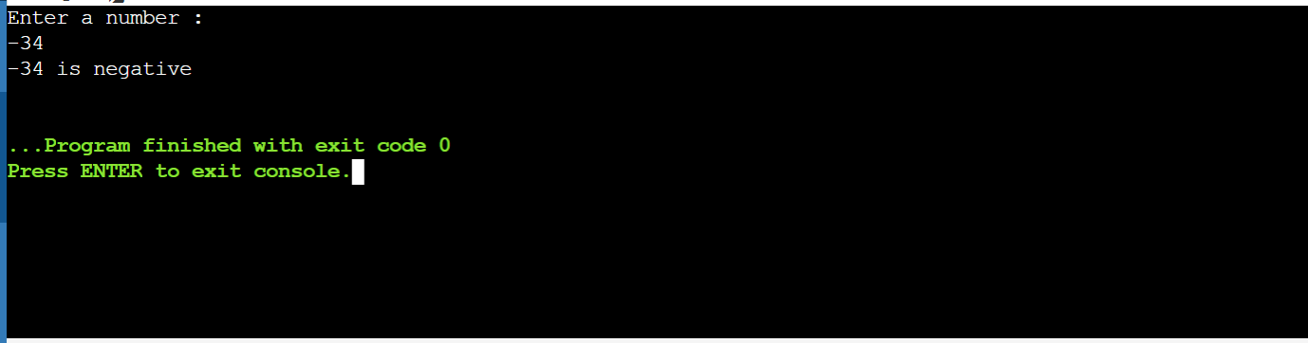

2.) import java.util.Scanner;

public class Main

{

public static void main(String[] args) {

int n;

Scanner s = new Scanner(System.in);

System.out.println("Enter a number from 1-7 : ");

n=s.nextInt();

if(n==1)

System.out.println("Monday");

else if(n==2)

System.out.println("Tuesday");

else if(n==3)

System.out.println("Wednesday");

else if(n==4)

System.out.println("Thursday");

else if(n==5)

System.out.println("Friday");

else if(n==6)

System.out.println("Saturday");

else if(n==7)

System.out.println("Sunday");

else

System.out.println("Please enter a valid choice from 1-7");

}

}

Output:

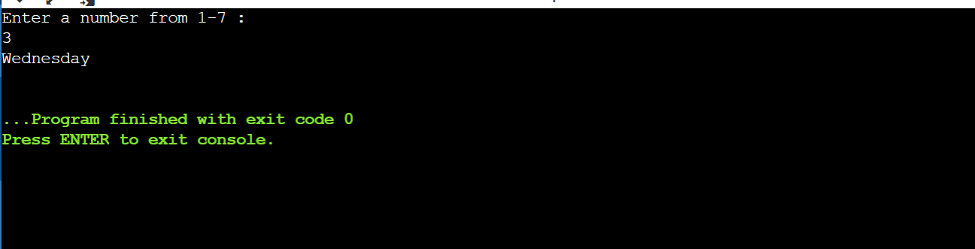

3.) import java.util.Scanner;

public class Main

{

public static void main(String[] args) {

Scanner s = new Scanner(System.in);

String c;

System.out.println("Enter the character :");

c=s.next();

if(c.length()>1){

System.out.println("Error");

}

else if (c.equals('a') || c.equals('A') || c.equals('e') || c.equals('E') || c.equals('i') || c.equals('I') || c.equals('o') || c.equals('O') || c.equals('u') || c.equals('U')){

System.out.println(c+ " is a vowel");

}

else{

System.out.println(c+ " is a consonant");

}

}

}

Output:

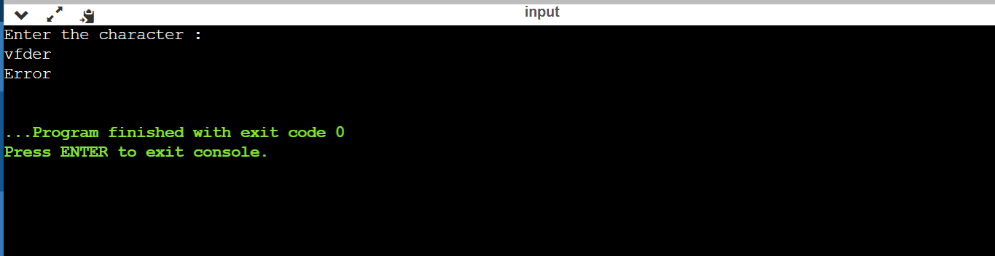

4.) import java.util.Scanner;

public class Main

{

public static void main(String[] args) {

System.out.println("Enter a year :");

Scanner s = new Scanner(System.in);

int n = s.nextInt();

if(n%400==0 || (n%4==0 && n%100!=0)){

System.out.println(n+" is a leap year");

}

else{

System.out.println(n+" is not a leap year");

}

}

}

Output:



5.) import java.util.Scanner;

public class Main

{

public static void main(String[] args) {

Scanner s = new Scanner(System.in);

System.out.println("Enter 1st number :");

int n1 = s.nextInt();

System.out.println("Enter 2nd number :");

int n2 = s.nextInt();

System.out.println("Enter 3rd number :");

int n3 = s.nextInt();

if((n1<n2)&&(n2<n3)){

System.out.println("Increasing Order");

}

else if((n1>n2)&&(n2>n3)){

System.out.println("Decreasing Order");

}

else{

System.out.println("Neither increasing nor decreasing");

}

}

